Rowshon Ali  
Kishorgong, Nilphamari  
Nilphamari, 5350  
Phone - 01773265062  
Email - mdrowshonali944@gmail.com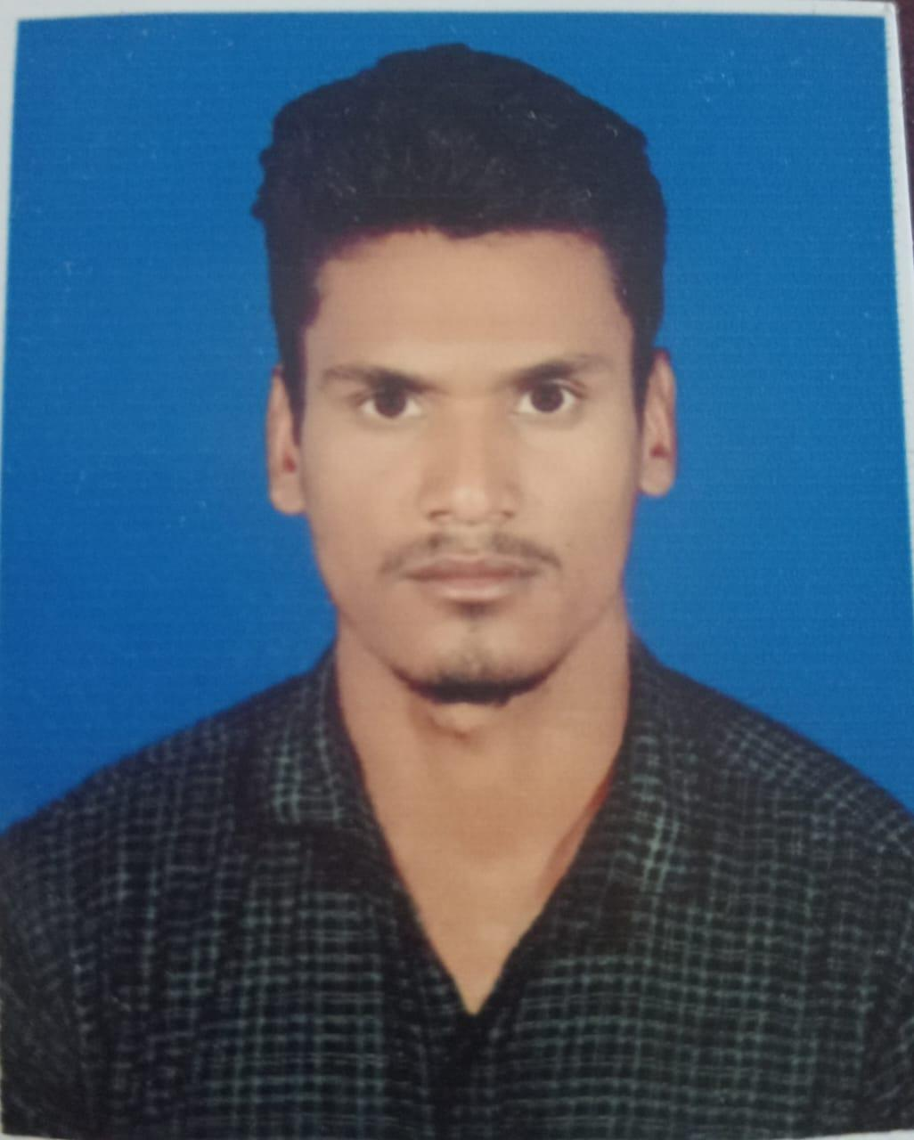

Github -https://github.com/Rowshonali62

Fiverr -https://www.fiverr.com/rowshon62

Linkedin-https://www.linkedin.com/in/md-rowshon-ali-03739834a

**Objective:***A proficient profession with expertise in MS word ,MS Office, MS powerpoint and data entry .Experienced in handing complex documentation , streamlining workflows , and delivering accurate and timely results .Adpet a multitasking, ensuring efficiency, and contributing to organization success with precosion and attention to detail.*

**Education**

**Bachelor of science-BSc**

University name :Nilphamari Govt College

Department name : Zoology

Session : 2019-2020

Result : 4.0 (Out of 4.0)

Passing year : 2023

**Higher School Certificate Examination (H.S.C)**

Institution name : Taragong Govt College

Board : Dinajpur

Group : Science

Result : 3.25.00(out of 5.00)

Passing Year : 2002019

**Secondary School Certificate Examination (S.S.C)**

Institution name :Chand Khana Maza Para high school

Board : Rajshahi Education Board

Group : Science

Result : 4.00.00(out of 5.00)

Passing Year : 2017

**Training**

**Computer Fundamentals and Office Applications Training**  
Organized by Bangladesh Computer Council and Center for Digital Transformation (CDT), Begum Rokeya University, Rangpur  
Funded by Enhancing Digital Government & Economy (EDGE) Project  
Year of Completion - 2025

* **Office Applications**: Microsoft Word, Excel, PowerPoint
* **Computer Fundamentals**: Hardware and software basics, troubleshooting
* Proficient Gained proficiency in basic computer operations and Microsoft Office applications.
* Hands-on experience with tools like Word, Excel, PowerPoint, and others.
* Learned essential skills for digital government services and economic applications.

**Technical Skills**

* in Microsoft Office Suite (Word, Excel, PowerPoint, Outlook)
* Basic computer troubleshooting
* Understanding of digital government services
* Strong attention to detail and organizational skills
* Excellent communication and teamwork abilities

**Projects:**

**Academic Marksheet**

I make an academic mark-sheet using MS Office 2016.

**Salary Sheet**

I make an academic mark-sheet using MS Office Excel 2016.

**Hostel Maintenance Sheet**

I make a Hostel Maintenance Sheet using MS Office Excel 2016

**Biography Presentation**

I make a biography presentation using MS Office PowerPoint 2016

**Certifications**

* **Computer Fundamentals and Office Applications Training**

**Languages**

* English (Fluent)
* Bangla (Fluent)

**References**

**Reference: 01**

Name - Md Yousuf Ali

Organization - Nilphamari Govt College

Designation - Lecturer Of ICT

**Reference: 02**

Name - Md. Jahangir Alam

Organization - Nilphamari Govt College

Designation - Associate Professor Of Chemistry